Weather Crisis Dashboard – Project Report

Project Description
This project is a real-time Weather Crisis Dashboard built using Python and Streamlit to retrieve live severe weather alerts from the National Weather Service API and present them through an interactive UI

Main Objectives
- To retrieve real-time severe weather alert data for any U.S. State
- To visualize alert data using charts and mapping
- Provide filter abilities based on alert type and severity
- To display detailed alert information in a user-friendly way
Significance of the project

Severe weather events such as tornadoes and flash floods put millions of lives at risk annually. Though people can find real-time data through the apps on their phones or new weather reports, it often lacks the ability for users to be able to interpret the data quickly due to a lack of visualization and accessibility. This project allows for severe weather data to be implemented into an interactive dashboard by combining the data with visual tools, which allow an improved user experience of awareness and accessibility to critical safety information. Unlike most weather platforms, this program is based on purely active crisis alerts and emphasizes clarity through filtering and active alert

Installation Requirements and Usage instructions
Library | What It Does
Streamlit | Turns Python into a web app with no HTML/CSS needed
Folium | Creates interactive maps in the browser
Plotly | Creates the interactive bar chart
Requests | Makes the HTTP call to the NWS API
Pandas | Organizes alert data into a table format for the chart

How to Run the App?
- Open VSCode
- Open the terminal (Ctrl + `)
- Navigate to the project folder:
cd C:\Users\”name”\weather-crisis-dashboard
pip install -r requirements.txt
- Run the app:
python -m streamlit run app.py

- Your browser opens automatically to http://localhost:8501
To stop the app: press Ctrl + C in the terminal

Usage
- Select State from dropdown menu
- Apply filters for severity and alert type
- View results through:
  - Summary metrics
  - Bar Chart visualization
  - Interactive map
  - Expandable alert descriptions

Code Structure

weather_api.py — Data Handling
This module is responsible for:
- Sending HTTP requests to the National Weather Service API
- Retrieving active alert data for a selected state
- Parsing and extracting relevant fields such as event type, severity, area, description, and timing
- Assigning color codes based on severity levels

map_utils.py — Map Generation
This module:
- Builds an interactive map using the Folium library
- Displays alert zones using geographic polygon data
- Applies color coding based on severity
- Handles cases where geographic data is missing

app.py — User Interface
This is the main application file built with Streamlit
- Manages user input (state selection and filters)
- Calls the API module to retrieve data
- Displays visual components such as charts, maps, d alert lists
- Refreshes dynamically when user input changes

Program Flow:
- User selects a state and filter options
- The application retrieves data from the API
- Data is processed and filtered
- Results are displayed through visual and textual components
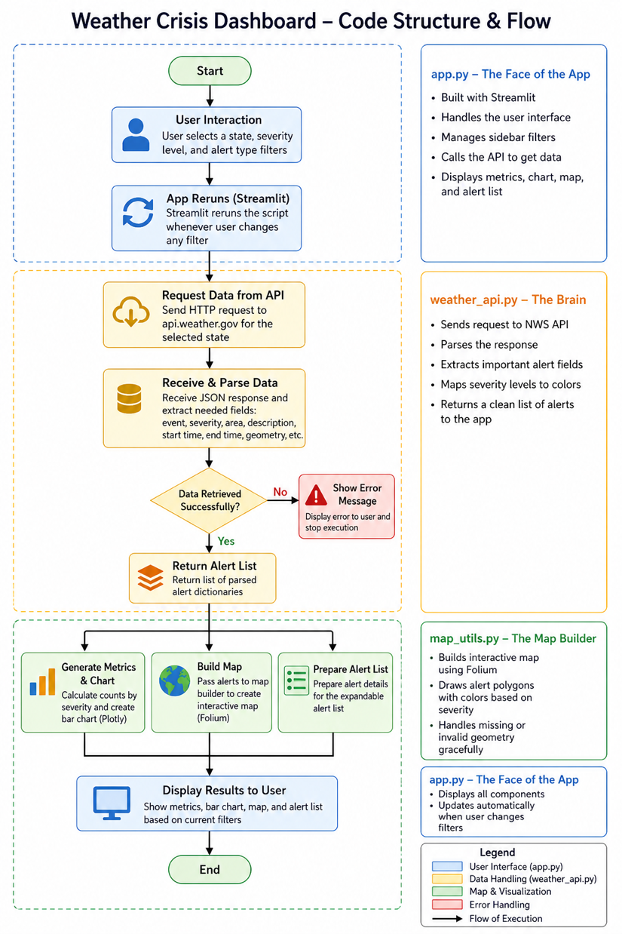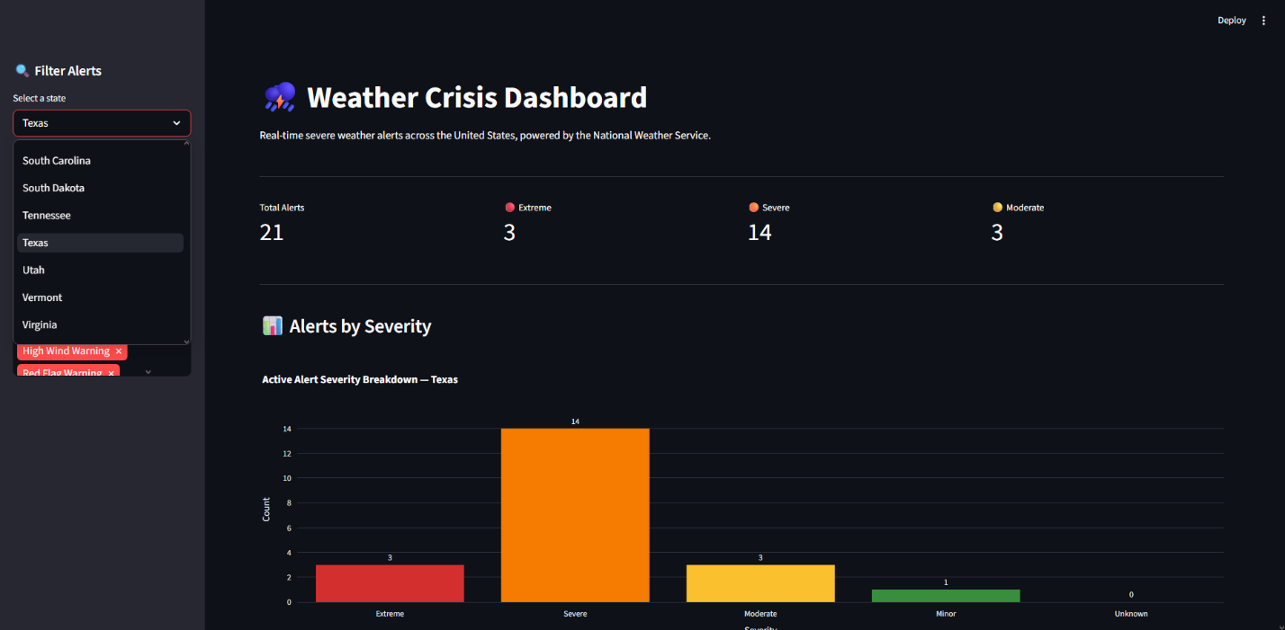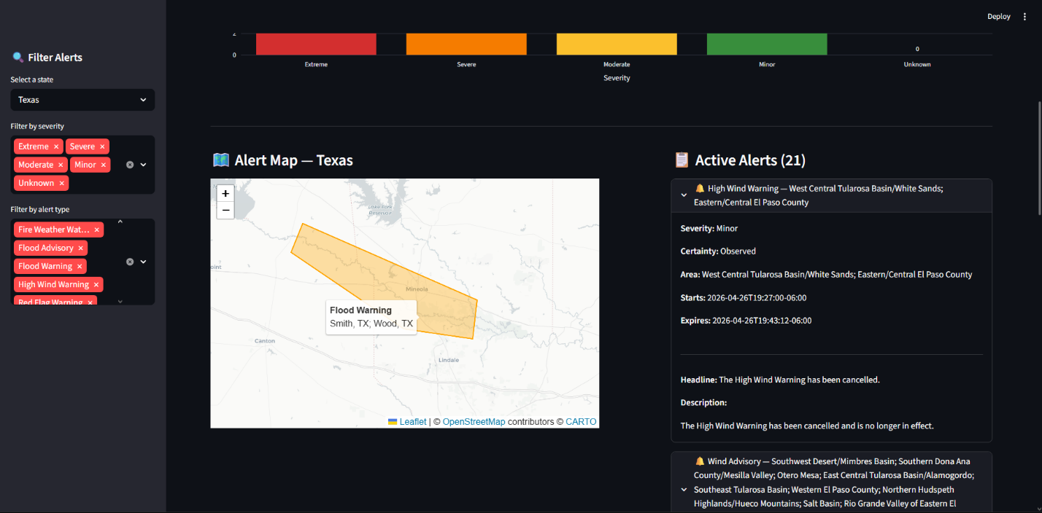

Functionalities and Test Results

Functionalities:
- Real-Time Data Retrieval
The system fetches live weather alerts from the API for any selected state.
- Filtering System
Users can filter alerts by severity (Extreme, Severe, Moderate, Minor) and alert type.
- Data Visualization
A bar chart displays the number of alerts by severity level.
- Interactive Map
Alert regions are displayed on a map using color-coded polygons.
- Detailed Alert Display
Users can expand individual alerts to view full details including descriptions and timestamps.

Test Results:
- API requests successfully returned real-time alert data for multiple states
- Filtering options correctly updated displayed results
- The bar chart accurately reflected alert counts
- The map displayed alert zones correctly when geographic data was available
- The system handled missing data without crashing
Overall, the application performed as expected with no critical errors during testing.

Showcasing the Achievement of Project Goals
The project successfully meets all defined objectives by integrating real-time data retrieval with visualization and user interaction.
Key achievements include:
- Accurate retrieval and display of live weather alerts
- Effective filtering system for user-specific queries
- Clear visualization through charts and maps
- Organized presentation of detailed alert information
The application interface provides:
- Summary statistics for quick insight
- A bar chart for severity distribution
- A geographic map highlighting affected areas
- A detailed alert list for in-depth information

- Main dashboard
- Bar chart
- Map visualization
- Alert detail view
These outputs demonstrate that the project effectively transforms raw data into meaningful and actionable information.

Discussion and Conclusions
During development, several challenges were encountered. One of the primary issues involved handling incomplete data from the API, particularly alerts that lacked geographic polygon information. This was addressed by implementing error handling to prevent application crashes.
Additional challenges included integrating multiple libraries and ensuring that real-time data updates functioned correctly within the application.

Limitations:
- Some alerts do not include geographic data, limiting map visualization
- The application requires an internet connection to function
- Performance may decrease with large volumes of data

Future Improvements:
- Add a nationwide view of all alerts across states
- Implement historical data tracking
- Introduce real-time notifications for critical alerts
- Enhance user interface design

Course Concepts Applied:
- API integration and HTTP requests
- Data structures (lists, dictionaries)
- Data visualization techniques
- Modular programming and code organization
This project demonstrates practical application of software development concepts in a real-world scenario.

Overall Quality of Report and Project
The project demonstrates a well-structured and fully functional system that integrates real-time data with interactive visualization. The code is modular, readable, and organized into separate components for clarity and maintainability.
The report provides a comprehensive explanation of the system, including its functionality, structure, and outcomes. Care has been taken to ensure clarity, logical flow, and completeness.

AI Usage
AI tools such as ChatGPT and Claude were used to assist with:
- Structuring the project report
- Explaining concepts and improving clarity
- Refining descriptions of system components
- Help with debugging and Setup of code
The AI provided guidance and suggestions; however, all coding, implementation, testing, and final decisions were completed by us.

